**Launching CC**

Condo Control is our management and resident communications portal

Condo Control’s simple and easy-to-use features include:

* File Library

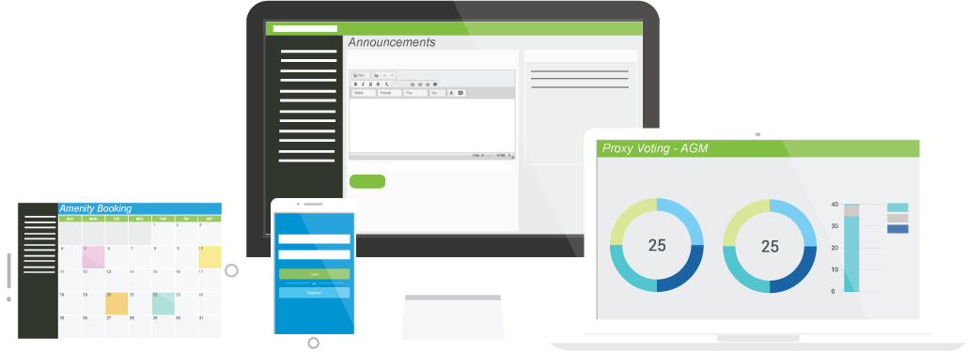

* Amenity booking
* Events calendar
* Discussion Forum
* Classified Ads
* Service Requests
* Announcements
* Mobile App
* And much more

Log in and register at when you receive your Welcome Letter from our property. We’re aiming to launch the system by {insert date}. If you have a valid email with management you will receive the welcome letter via email and if you do not have an email, you will receive a paper copy of the welcome letter.

Once you receive your Welcome Letter, log in at [CondoControlCentral.com/registration](http://www.CondoControlCentral.com/registration)   
and enter your temporary password and unit number.

The goal is to have a system in place where our residents will be able to book amenities online, take advantage of payment for the amenities via credit card, have the ability to download documents from the Library function and streamline the communication from property management and residents. After that, Condo Control will be the only platform we’ll use. We won’t have all of Condo Control’s functions enabled right away but over time will take advantage of new function that’s built in, ready for us.